1. Project Objective and Description

1.1 Project Selection
For the final project of the Selected Topics in Financial Engineering course, our team chose to create and deploy an Automated Market Maker (AMM). Specifically, we developed a Constant Function Market Maker (CFMM) utilizing the standard constant product formula to facilitate decentralized token swaps. This satisfies the core requirement of building a fully functional smart contract in Solidity. To support this ecosystem, we also minted and deployed two newly created ERC20 tokens, SYX and ZHC, to act as the pool's base and quote assets.

1.2 Motivation & Expectations
As a two-person team, our objective was to go beyond a basic decentralized exchange implementation and integrate advanced functionality to increase the rigor and originality of the project. Our primary motivation was to explore DeFi composability by designing a hybrid AMM that embeds a native collateralized lending market directly into the swap protocol. Rather than relying entirely on external Layer 2 lending protocols, our smart contract allows users to deposit SYX as collateral to borrow ZHC directly from the AMM's liquidity reserves.
Our expectation for this project is twofold. First, we aim to demonstrate a technically rigorous Solidity implementation that manages liquidity pool mechanics, swap fees, and lending interest accrual simultaneously within a single state architecture. Second, we expect to mathematically validate our protocol's economic viability. By building a comprehensive local Python simulation environment, we intend to analyze the complex price dynamics driven by random traders, arbitrageurs, and borrowers, ultimately evaluating the impact of these combined mechanics on the liquidity providers' impermanent loss and overall profitability.

2. Core Smart Contract Architecture (AMM)

2.1 Token Ecosystem
To construct the foundation of our decentralized exchange, we designed and deployed two custom ERC20 tokens representing the base and quote assets of our liquidity pool: SYX (Token A) and ZHC (Token B). Both token contracts inherit from the widely audited OpenZeppelin ERC20 standard to ensure robust security and compliance with the Ethereum ecosystem. Upon deployment, the constructors mint an initial supply of 1,000,000 tokens (scaled by standard 18 decimal places) to the deployer's address, which is subsequently used to seed the initial liquidity pool.

2.2 CPMM Mathematical Model
Our protocol utilizes a Constant Function Market Maker (CFMM) model, specifically adhering to the Constant Product Market Maker (CPMM) invariant. The core mathematical foundation is defined by the formula $x ⋅y = k$, where x represents reserveA (SYX), y represents reserveB (ZHC), and k is the constant product invariant.
Because an AMM acts as its own internal price oracle, the spot price of an asset is deterministically derived from the ratio of the reserves. Our contract natively computes these spot prices via getPriceSYXInZHC and getPriceZHCInSYX. To handle Solidity's lack of floating-point arithmetic, the internal price calculation multiplies the numerator by ${10}^{18}$ before division, ensuring high-precision output: $P_{SYX/ZHC}=\frac{reserveB⋅{10}^{18}}{reserveA}$.

2.3 Fee Structure
To incentivize liquidity provision and capture protocol revenue, the smart contract implements a granular fee architecture using basis points (BPS), where the denominator is set to 10000. The total fee applied to every swap is 0.30% (TOTAL_FEE_BPS = 30).
This total fee is algorithmically split into two components during execution:
Liquidity Provider Fee (0.25%): Represented by LP_FEE_BPS = 25, this portion stays within the pool's reserves (reserveA or reserveB), organically growing the value of the LP shares over time.
Protocol Fee (0.05%): Represented by PROTOCOL_FEE_BPS = 5, this portion is explicitly deducted from the input amount and routed into isolated state variables (protocolFeesA and protocolFeesB). By decoupling protocol fees from the active liquidity reserves, the contract prevents LPs from inadvertently claiming protocol revenue upon withdrawal. The designated feeRecipient (admin) can extract these accumulated fees by calling the withdrawProtocolFees function.

2.4 Liquidity & Swap Mechanics
Liquidity Operations:
When liquidity is added for the very first time (totalShares == 0), the contract mints shares equal to the geometric mean of the deposited amounts: $S=\sqrt{amountA⋅amountB}$. For all subsequent deposits, the contract mints shares proportionally to the existing reserves to prevent dilution, calculating the minimum ratio to enforce balanced deposits: $S=\min\left(\frac{amountA⋅totalShares}{reserveA},\frac{amountB⋅totalShares}{reserveB}\right)$. Upon liquidity removal, users burn their shares to receive a strictly proportional cut of the current reserves: $amount=\frac{share⋅reserve}{totalShares}$.
Swap Routing:
Swaps are executed via the getAmountOut function, which determines the exact output amount based on the constant product invariant adjusted for the total fee. The output calculation operates strictly on the 0.30% fee-adjusted input amount:
$$Δx_{after_fee}=\frac{Δx⋅\left(10000-30\right)}{10000}$$
$$Δy=\frac{Δx_{after_fee}⋅reserve_{out}}{reserve_{in}+Δx_{after_fee}}$$
To prevent severe price impact and front-running (MEV), the swap functions (swapSYXForZHC and swapZHCForSYX) implement a minAmountOut parameter, reverting the transaction if the calculated output falls below the user's defined slippage tolerance.

3. Advanced Functionality: Integrated Lending Market

3.1 Collateral & Borrowing Mechanism
To elevate the complexity of our project and fulfill the advanced functionality requirement, we engineered a native collateralized lending market directly into the AMM. Instead of relying on external Layer 2 lending protocols like Aave, our smart contract acts as both the decentralized exchange and the lending pool.
Users can supply SYX (Token A) to the protocol via the depositCollateral function, which locks the assets into the contract's collateralSYX mapping. Once collateralized, users can call the borrowZHC function to borrow ZHC (Token B). A critical design choice in our architecture is that borrowed funds are drawn directly from reserveB (the AMM's active liquidity for ZHC). This creates a highly capital-efficient environment where idle swap liquidity doubles as lending liquidity, though it simultaneously introduces complex state dependencies between swap execution and borrowing capacity.

3.2 Risk Management (LTV & Interest)
To protect the liquidity pool from insolvency, the protocol enforces strict risk management parameters:
- Loan-to-Value (LTV) Ratio: The contract hardcodes a maximum LTV of 50%. When a user attempts to borrow, the getBorrowLimitZHC function calculates the USD-equivalent value of their SYX collateral denominated in ZHC using the internal spot price, and caps the borrowing power at exactly half of that value.
- Interest Accrual: Debt incurs an Annual Percentage Rate (APR) of 5%, defined by ANNUAL_INTEREST_BPS = 500. The protocol uses a continuous simple interest model computed via the _accrueInterest helper function. Every time a user interacts with their debt position (borrowing, repaying, or withdrawing collateral), the contract calculates the seconds elapsed since the lastAccruedTime and rolls the accrued interest into the debtPrincipalZHC.
- Repayment: When users call repayZHC, the contract first updates the accrued interest. The repaid ZHC is then routed back into reserveB, replenishing the AMM's liquidity pool and decreasing the user's outstanding debt.

3.3 Known Limitations & Security Considerations
While our integrated lending AMM functions perfectly within a controlled or isolated environment, we proactively identified a significant security vulnerability in its current architecture regarding price oracle manipulation.
Currently, the borrowing limit relies on the getPriceSYXInZHC function, which determines the collateral's value based strictly on the current ratio of the AMM's internal reserves ((reserveB * 1e18) / reserveA). In a real mainnet environment, this design is highly susceptible to Flash Loan attacks. A malicious actor could take out a massive flash loan to heavily skew the reserves via a swap, artificially inflating the price of SYX. They could then deposit a small amount of SYX, borrow a disproportionately large amount of ZHC against the manipulated price, and drain the pool's liquidity.
As a critical learning outcome of this project, we recognize that a production-ready version of this contract must integrate a robust, manipulation-resistant pricing mechanism. To resolve this, future iterations would require either the implementation of a Time-Weighted Average Price (TWAP) oracle, or the use of an external decentralized oracle network, such as Chainlink, to bring in secure, off-chain price data as recommended in the advanced functionality guidelines.

4. Rigor of Methodology: Local Simulation Setup

4.1 Simulation Objective
To validate the economic viability of our protocol and ensure the rigor of our methodology, we developed a comprehensive local Python simulation environment. Deploying an AMM with integrated lending introduces complex state dependencies that are difficult to evaluate statically. The objective of this simulation is to stress-test the constant product market maker (CPMM) model over a 1000-day period, evaluating the protocol's stability, the efficiency of arbitrage mechanisms, and the long-term impact on the Liquidity Provider's (LP) portfolio, specifically measuring unrealized P&L and impermanent loss against a standard HODL strategy.

4.2 Market Environment Modeling
To simulate realistic external market dynamics, we modeled the absolute prices of SYX and ZHC using Correlated Geometric Brownian Motion (GBM). This stochastic process ensures that the simulated prices exhibit continuous paths with proportional volatility, reflecting real-world cryptocurrency market behaviors.
The price updates follow the discrete-time GBM equation:
$$S_{t+Δt}=S_{t}\exp\left(\left(μ-\frac{σ^{2}}{2}\right)Δt+σ\sqrt{Δt}Z\right)$$
In our implementation, we defined a daily time step ($dt=\frac{1}{365}$) and established specific drift and volatility parameters for each asset:
- SYX (Base Asset): $μ_{x}=,σ_{x}=0.4$
- ZHC (Quote Asset): $μ_{y}=0.03$, $σ_{y}=0.10$
To account for the macroeconomic correlation between crypto assets, we introduced a correlation coefficient of $ρ= 0.3$. The external relative market price, which serves as the target for arbitrageurs, is continuously derived as $P_{market}=\frac{P_{SYX}}{P_{ZHC}}$.

4.3 Agent-Based Modeling
We constructed an agent-based model to simulate the interaction of four distinct market participants with the smart contract logic:
- Liquidity Provider (LP): Acts as the baseline passive participant. The LP initializes the pool with 100,000 SYX and 100,000 ZHC. The simulation tracks the USD value of their active AMM position (including outstanding ZHC debt owed to the pool) and compares it against a static holding to calculate impermanent loss.
- Trader: Simulates retail volume and protocol fee generation. The trader interacts with the pool at a frequency governed by a Poisson distribution ($λ= 5$ trades per day). The size of each trade is determined by a Lognormal distribution ($μ= 5, σ= 1$), and the direction (buying SYX or ZHC) is uniformly randomized.
- Borrower: Introduces liquidity shocks and tests the lending mechanics. The borrower operates on randomized probabilities: there is a 5% daily chance to deposit SYX collateral and borrow ZHC up to a 40% Loan-to-Value (LTV) ratio (safely below the 50% hard cap). Conversely, if debt exists, there is a 5% probability of repaying the principal plus the accumulated 5% APR interest.
- Arbitrager: The core price-correction engine. The arbitrager continuously monitors the divergence between the AMM's internal spot price and the external GBM market price. If the price discrepancy exceeds the total pool fee (0.30%), an arbitrage opportunity exists. To maximize profit and perfectly realign the pool's price with the external market, the arbitrager solves a bounded objective function using SciPy's minimize_scalar optimization algorithm. This determines the exact optimal swap volume ($Δx$ or $Δy$) required to extract value while restoring equilibrium.

5. Simulation Results and Data Analysis

5.1 Price Discovery and Arbitrage Efficiency
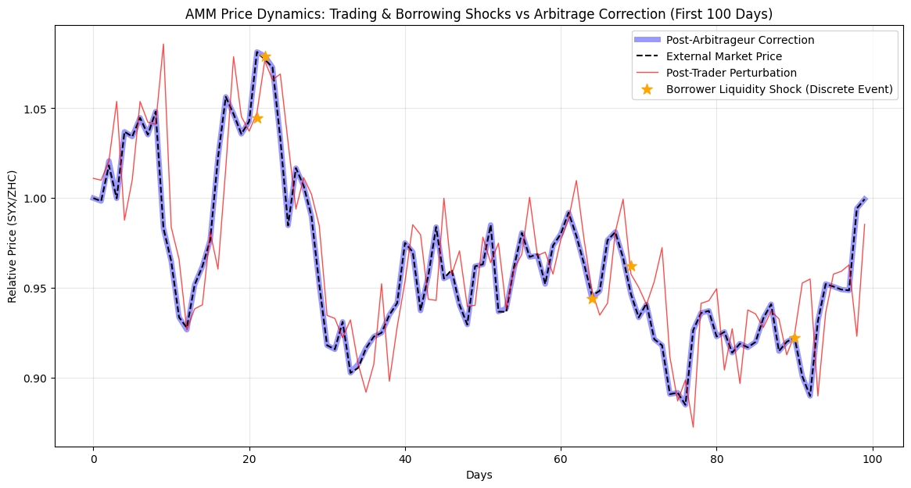
The simulation of the first 100 days confirms that the AMM's internal pricing mechanism effectively tracks the external market when subjected to arbitrage forces. The price dynamics plot illustrates three distinct market interactions:
- Retail Perturbation: Random trading volume (red line) continuously pushes the AMM's internal relative price away from the external Correlated GBM market price (black dashed line).
- Liquidity Shocks: The native lending feature introduces discrete volatility. When borrowers extract ZHC from the pool (orange stars), it instantaneously alters the reserve ratio, causing immediate price slippage.
- Arbitrage Correction: Despite the frequent deviations caused by traders and borrowers, the post-arbitrageur correction (blue line) tightly hugs the external market price. This proves that the minimize_scalar optimization algorithm successfully identifies and executes the exact swap volume required to realign the pool's ratio, maintaining an efficient market.

5.2 Liquidity Provider (LP) Performance and Impermanent Loss
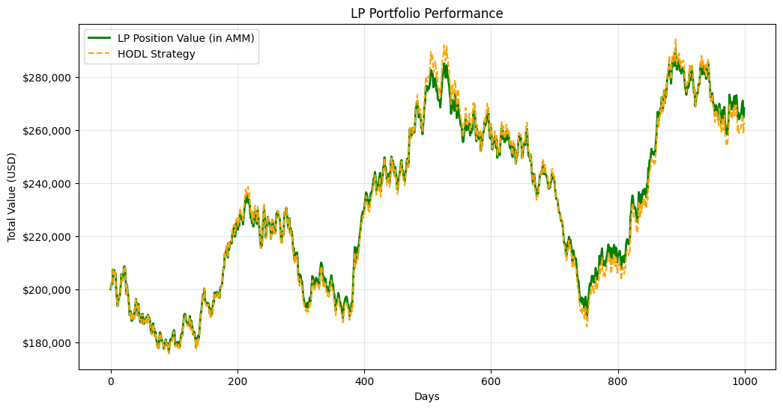
Results | Amount
LP Unrealized P&L (USD) | $68,224.77
LP Impermanent Loss (USD) | $5,438.10
Protocol Accumulated Fees (USD) | $1,533.07
Arbitrager Total Profit (USD) | $18,249.76
The 1,000-day portfolio performance comparison reveals the fundamental trade-offs of providing liquidity in a CPMM pool.
- Unrealized P&L: The LP concluded the simulation with an Unrealized P&L of $68,224.77. Both the AMM position and the HODL strategy grew significantly over the period, which is a direct result of the positive drift parameters ($μ_{x}=0.05,μ_{y}=0.03$) assigned to the simulated assets.
- Impermanent Loss (IL): The LP experienced an Impermanent Loss of $5,438.10. As the external prices of SYX and ZHC diverged due to volatility and their 0.3 correlation, the AMM automatically sold the outperforming asset and bought the underperforming asset. Consequently, the LP's position value (green line) slightly underperformed a static 50/50 initial holding (orange dashed line). The LP fees collected (0.25% per trade) were insufficient to completely offset the divergence loss over the 1,000-day horizon.

5.3 Value Extraction and Protocol Revenue
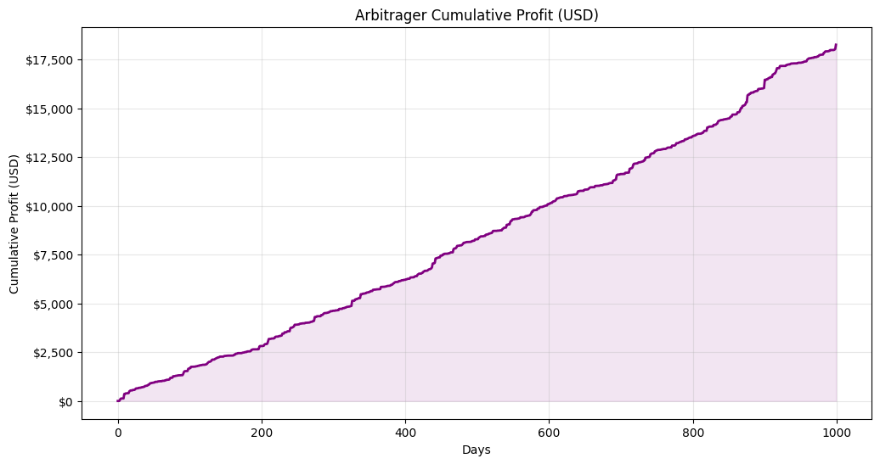
The simulation output highlights the distribution of value extracted from the pool over the 1,000-day period:
- Arbitrager Profitability: The arbitrageur realized a total cumulative profit of $18,249.76. The profit curve displays a steady, monotonic increase, indicating that the constant volatility and regular borrower shocks provide a continuous stream of arbitrage opportunities. This represents value explicitly extracted from the LP's reserves to pay for price discovery.
- Protocol Revenue: The smart contract successfully isolated the 0.05% protocol fee, accumulating a total of $1,533.07. This confirms that the mathematical routing in the getAmountOut function accurately segregates protocol revenue from LP equity without disrupting the constant product invariant.

6. Summary and Learnings

6.1 Summary of Project Steps
To accomplish this assignment, our team executed the following steps:
- Protocol Design: Formulated the economic architecture for a hybrid AMM combining Constant Product Market Maker (CPMM) swap mechanics with a native collateralized lending market.
- Smart Contract Development: Authored and compiled AMM.sol, SYXToken.sol, and ZHCToken.sol using Solidity and the OpenZeppelin library, implementing state variable management and precise fee routing (0.25% LP, 0.05% Protocol).
- Mathematical Simulation: Developed a Python testing environment using Correlated Geometric Brownian Motion (GBM) to simulate external market volatility and model the interactions between liquidity providers, traders, borrowers, and arbitrageurs.
- Data Analysis: Executed a 1,000-day simulation to extract unrealized profit and loss metrics, impermanent loss data, and protocol revenue.
- Deployment: Published and verified the fully functional smart contracts on the Ethereum testnet.

6.2 Strategy and Pre-defined Assumptions
Our strategy for analyzing the unrealized profit and loss of the liquidity provider was grounded in several pre-defined assumptions:
- Market Dynamics: The external absolute prices of SYX and ZHC strictly follow a Correlated GBM with fixed drifts ($μ_{x}=0.05,μ_{y}=0.03$), volatilities ($σ_{x}=0.40,σ_{y}=0.10$), and a correlation coefficient of $ρ=0.3$.
- LP Strategy: The Liquidity Provider acts passively, holding the initial 50/50 token position within the AMM for the duration of the simulation to capture the 0.25% swap fees, without dynamically rebalancing to mitigate divergence.
- Risk Parameters: The lending market operates under a hardcoded 50% Loan-to-Value (LTV) limit and a 5% simple APR, assuming borrower behavior and collateral ratios prevent the accumulation of bad debt within the simulation timeframe.

6.3 Key Learnings
Through the development and simulation of this project, we acquired substantial insights into both smart contract engineering and decentralized finance mechanics:
- Smart Contract Security & Oracle Dependency: We learned the critical danger of relying on internal AMM reserves for price discovery. Using the spot price (reserveB / reserveA) to determine borrowing capacity exposes the protocol to severe flash loan manipulation. A production-ready environment necessitates bringing in external data via an oracle (such as Chainlink).
- Solidity Arithmetic Limitations: Due to Solidity's lack of floating-point arithmetic, we learned to manage precision meticulously. We utilized Basis Points (BPS) for fee calculations and ${10}^{18}$ scaling factors for price divisions to prevent truncation errors and ensure accurate fractional token distribution.
- The Cost of Price Discovery: The simulation data clearly demonstrated that arbitrage is not merely an exploitative mechanism for external actors, but the essential engine for AMM price discovery. The arbitrager's continuous cumulative profit represents the exact cost the LP pays (manifested as Impermanent Loss) to keep the internal market synchronized with the broader external ecosystem.
- Capital Efficiency vs. Systemic Risk: Integrating lending directly into the swap liquidity pool increases capital efficiency, as idle assets concurrently support swap routing and collateralized loans. However, we learned this drastically increases systemic risk; a sudden extraction of reserveB by borrowers directly impacts the constant product invariant, causing immediate and severe price slippage for regular traders.

